Team: Data Junkies
Project: Employee Database Application
Project Deliverable: Week 5

Team Participation Report

Bill Wodon (Team Leader): 60%
Added new pre and post conditions
Added the complex conceptual constraionts

Tom Paracelcius: 40%
Revised Operations

Together
Did the relational schema together

Requirements

An Employee Database Application keeps track of all employees of a small company, including their name, job and salary. The company is divided into departments (with a name and location), and every employee works for a single department.

Only employees can successfully login to the system, however, even without logging in, a user can get the names and locations of all the company departments.

An employee can optionally provide and change their own address, and can see the address of any other employee who has provided an address and made it public, given that employee's name. An employee can see a list of the names and jobs of all the employees in their own department, and can find out the department and location of another employee given their name.

Every employee (except for the President – the employee whose job is 'PRESIDENT') has a manager, who directly manages them. An employee does not need to be in the same department as their direct manager. However, every employee works at the same location as their direct manager, unless they are directly managed by the President. When a manager is terminated, all employees who directly reported to them instead will instead report to their old manager’s manager. Managers can get a list of all the employees that they directly manage, or all employees beneath them in the management hierarchy, along with the job, salary and manager of each.

Every department has at most one department manager (the employee in a department whose job is 'DEPTMGR'), and must have a department manager if it has a clerk. Any employee can find out the managers of the various departments. Every department manager may also directly manage employees, and all department managers are directly managed by the president.

A department manager can see the job, salary and manager of all other employees in their department, and can change the jobs and salaries of all the other employees in their department, and terminate employees in their department. A department manager can hire a new employee for their department, only if their initial direct manager is also in the same department. A department manager can change the direct manager of an employee in their department only if both the old and the new manager are in the same department.

A department without a manger has an acting manager (as long as the department has employees). When a department loses its manager or acting manager, the employee in the department with the highest salary (or one of them if there is more than one) becomes the acting dept manager.
The president can see and change the jobs, salaries, managers, and departments of all other employees, and can hire and terminate any other employee. The President can also create and destroy departments and move them to a new location. When destroying a department, the President can choose to either terminate all the employees in the department, or move them all together to a different department. However, no operation can affect the president.
Entity-Relationship Diagram

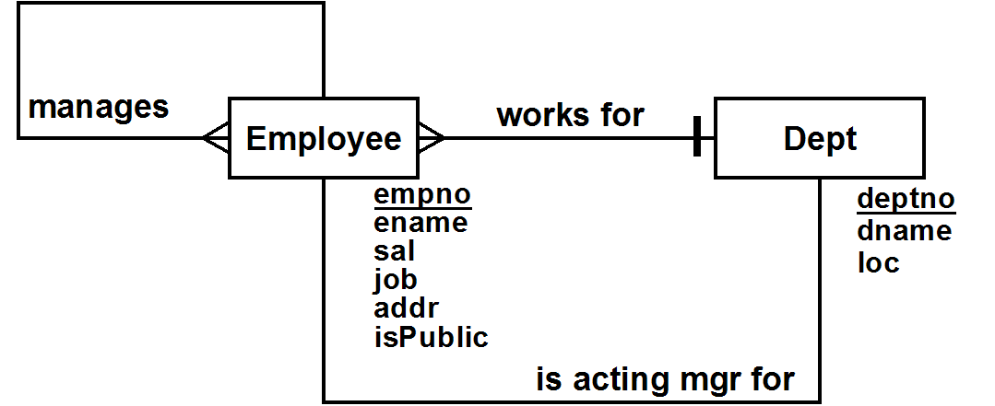

Entity Classes & Constraints

Employee
- Every employee has a name and job
- isPublic is either T or F (F is the default value)
- Only one employee has the job of PRESIDENT
- empno is larger than 1
- sal is not smaller than 100
Dept
- Every department has a name and location
- Every department name is unique
- Department numbers are all > 9
Relational Schema Diagram
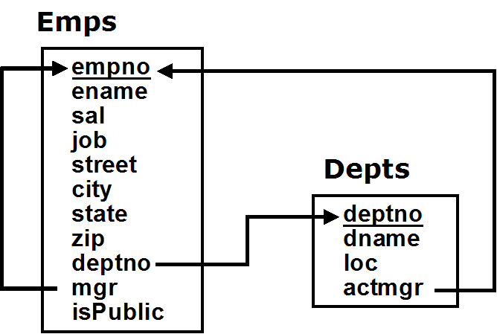

User Role Diagram

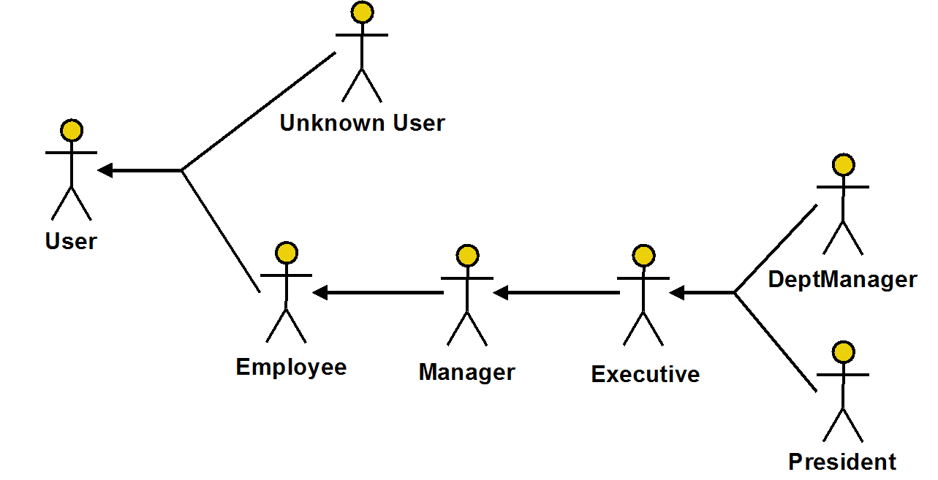

User Operations

User
Query
ShowAllDepts: Show the names & locations of all departments

Unknown User
Actions
Login( :empno, :pwd ): Login the specified user

Employee
Queries
ShowAddr( :ename ): Show the address of another employee,
if public, given their name
ShowDeptEmps: Show names & jobs of all employees who work in my department
ShowDeptLoc( :ename ): Show the dept and location of another employee,
given their name
GetMyInfo: Get my personal information
Actions
ChangeAddr( :addr, :isPublic ): Set/change my address, and mark it public or not
SetPwd( :oldpwd, :newpwd, :confpwd ): Changes password
Logout: Logout the current user

Manager
Queries
ShowDirect: Show the name, department and job of all the employees who report directly to me
ShowBelow: Show the name, department & job of all the employees who work underneath me

Executive
Queries
ShowCtrlEmps: Show info about employees I control
Actions
AddEmp( :empno, :ename, :sal, :job, :mgr, :deptno ): Hire an employee
ChangeJob( :empno, :job ): Change the job of an employee
ChangeSal( :empno, :sal ): Change the salary of an employee
ChangeMgr( :empno, :mgr ): Change the manager of an employee
ChangePosition( :empno, :deptno, :mgr, :job ): Change the department and/or possibly manager and/or job of an employee
TerminateEmp( :empno ): Terminate an employee

President
Actions
CreateDept( :deptno, :dname, :loc ): Create a new department
DestroyDept( :deptno, :newdept ): Destroy an existing department, possibly moving its employees to a new department
MoveDept( :deptno, :newloc ): Move a department to a different location

Actions with Interesting State-Related Post-Conditions

AddEmp
- If a dept mgr is hired into a dept with an acting mgr, the acting mgr loses that role

ChangeJob
- If an employee is promoted to become the dept mgr of a dept, the acting mgr loses that role
- If a dept mgr is demoted, the acting mgr becomes the highest paid employee in the dept

ChangePosition
- If an employee becomes the dept mgr of a dept, the acting mgr of that dept (if there is one) loses that role
- If a dept loses its dept mgr, the highest paid employee in the dept (if there is one) becomes the acting mgr

TermnateEmp
- If a dept loses its dept mgr, the highest paid employee in the dept (if there is one) becomes the acting mgr
- If the terminated employee managed other employees, then their direct manager is changed to the person who managed the terminated employee

DestroyDept
- When a department is destroyed, all its employees are either terminated or moved to another department
- If a terminated employee managed other employees, then their direct manager is changed to the person who managed the terminated employee

Operations with Identity-Based User Pre-Conditions

Login
- a user can’t login if already logged in

AddEmp
- a dept mgr can only hire an employee into their dept, and if their initial direct manager is in the same dept

ChangeJob
- an employee can't change their own job
- a dept mgr can only change the jobs of employees in their own department

ChangeSal
- an employee can't change their own sal
- a dept mgr can only change the salaries of employees in their own department

ChangePosition
- an employee can't change their own job, mgr or dept
- a dept mgr can only change the jobs of employees in their own department
- a dept mgr can only change the mgr of employees in their own department, and then only if both the old and new mgr are in their dept as well
- a dept mgr cannot change an employee's dept

TerminateEmp
- an employee can't terminate themselves
- a dept mgr can only terminate employees in their own dept

Queries with Interesting Output-Related Post-Conditions

ShowAddr
- Only shows employees who allow their address to be public

ShowCtrlEmps
- if the user is a dept mgr, only shows information about employees in their department.
Complex Conceptual State Constraints Enforced by Check Constraints

➔ NoPrezMgr
The President does not have a manager

In Emps, CHECK( job <> 'PRESIDENT' OR mgr IS NULL )

➔ EmpMgr
Every employee other than the President has a manager

In Emps, CHECK( job = 'PRESIDENT' OR mgr IS NOT NULL )

Complex Conceptual State Constraints Requiring Other Enforcement

➔ OnePrez
Constraint: Only one employee has the job of president
Operations: AddEmp, ChangeJob, ChangePosition
Tables: Emps

➔ ManageCirc
Constraint: No one manages themselves, their manager, their manager's manager, etc.
Operations: AddEmp, ChangeMgr, ChangePosition
Tables: Emps

➔ ManageDeptMgr
Constraint: All department managers are directly managed by the President (if there is one, or by no one if there isn't)
Operations: AddEmp, ChangeMgr, ChangeJob, ChangePosition
Tables: Emps

➔ OneDeptMgr
Constraint: Every department with employees either has one department manager or an acting manager who works for that dept, but not both
Operations: AddEmp, ChangeJob, ChangePosition, TerminateEmp
Tables: Emps

➔ DeptMgrClerks
Constraint: Every department that has a clerk has a dept manager
Operations: AddEmp, ChangeJob, ChangePosition, TerminateEmp
Tables: Emps

➔ ManageLoc
Constraint: Every employees works at the same location as their direct manager, if they have one, unless their direct manager is the president
Operations: AddEmp, ChangeMgr, ChangePosition
Tables: Emps, Depts

Manifest Views

➔ OneDeptMgr
Every department with employees either has one department manager or an acting manager who works for that dept, but not both

Manifest View:
-- For each department, provides count of #employees, actmgrs & deptmgrs

CREATE VIEW DeptMgrsView AS
SELECT deptno,
(SELECT count(*) FROM Emps e
WHERE e.deptno = d.deptno) AS eknt,
(SELECT count(*) FROM Emps e
WHERE e.deptno = d.deptno AND e.empno = d.actmgr) AS aknt
(SELECT count(*) FROM Emps e
WHERE e.deptno = d.deptno AND e.job = 'DEPTMGR') AS mknt
FROM Depts d

➔ DeptMgrClerks
Every department that has a clerk has a dept manager

Manifest View:
-- For each dept, has # of clerks (cknt) & # of deptmgrs (mknt)

CREATE VIEW DeptClerkMgrs AS
SELECT deptno,
(SELECT count(*) FROM Emps e
WHERE e.deptno = d.deptno AND e.job = 'CLERK') AS cknt
(SELECT count(*) FROM Emps e
WHERE e.deptno = d.deptno AND e.job = 'DEPTMGR') AS mknt

➔ ManageLoc
Every employees works at the same location as their direct manager, if they have one, unless their direct manager is the president

Manifest View:
-- for each employee with a mgr, indicates their job, dept and their dept location
-- their mgr, and their mgr's job, dept, and dept location

CREATE VIEW MgrLocsView AS
SELECT e.empno AS eno, e.loc AS eloc,
m.empno AS mno, m.loc AS mloc, m.job AS mjob
FROM EmpsDept e, EmpsDept m WHERE e.mgr = m.empno

